**Classified Ad for Web site**

**Wanted:** Two doors in Photo-etch paper finish as photo. Size required is 29" High X 9.1/2" wide.

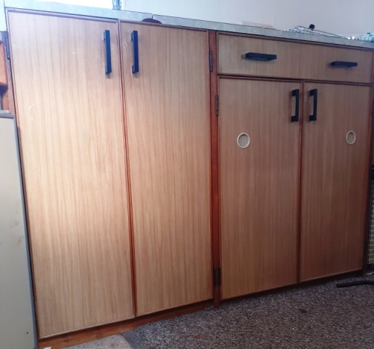 **Contact Chuck Berry -  chuck@hkb.co.uk; tel: 01747 811625 or 07860 294240**